Redox Chemistry Metal Magician
Theory Redox Reactions
- Reduction and Oxidation reactions
- Occur simultaneously
- Involve the transfer of electrons

The reaction between iron and copper(II) sulfate is a redox reaction. Make observations during the reaction and draw a diagram to explain the reaction that is occurring.

Materials
- 1 × test tube
- 10 mL of 1.0 M CuSO₄
- Iron (steel) wool
- Glass stirring rod
- 10 mL measuring cylinder
- Test tube rack

Procedure
- Place test tube in a test tube rack
- Place some iron wool in the text tube, pushing it to the bottom with a glass stirring rod
- Add 10 mL 1.0 M CuSO₄ to the test tube

Observations:

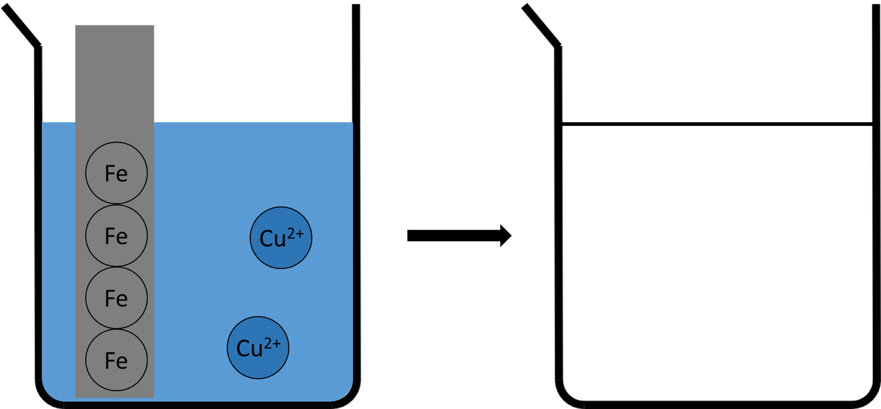
Acid Base Chemistry Solution Detective

Supporting material for Lukins, N. et al. (2010), Experiment 45 Unknown solutions, Heinemann Chemistry 1 teacher’s resource and assessment book 4th edition, Harcourt Education, Port Melbourne, Australia.
Purpose
You have been provided with four unknown samples, A-D. In no particular order, the unknown samples are:
- 0.1 M HCl
- 1.0 M HCl
- 0.1 M NaOH
- Water, H₂O

The aim of the investigation is to experimentally identify unknown samples A-D. You will be provided with the indicator methyl orange. The details for methyl orange are shown below.
Extract from VCAA Data Book, Acid-base Indicators
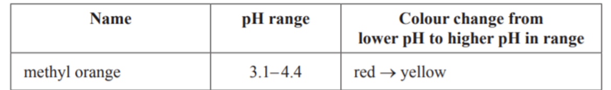
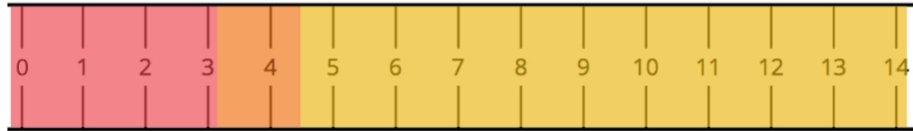

Materials
- 1 × multi-well plate
- 4 unknown samples labelled A-D
- Methyl orange indicator
- 5x transfer pipettes

Theory
Before you begin, consider what samples of water, 0.1 M NaOH, 0.1 M HCl and 1.0 M HCl might look like at the molecular level by colouring in the particles that make up each liquid/solution. Predict the pH of each sample and the colour if methyl orange was added to each.
Key
H₂O | H⁺ | OH⁻

H₂O  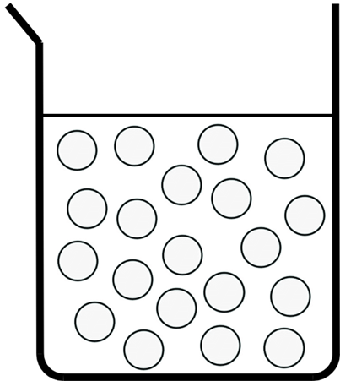 | 0.1 M OH⁻
Predicted pH:  Predicted colour: | Predicted pH:  Predicted colour:
1.0 M H⁺ | 0.1 M H⁺
Predicted pH:  Predicted colour: | Predicted pH:  Predicted colour:
Procedure
Write a procedure of how you plan to identify the four unknown samples using only the materials available to you. Explain your thinking.

Results
Record you observations in a table.

Conclusion
State the identity of the four unknown substances in the table below.
A | B | C | D

Clue
Combine equal amounts of each unknown.
 | H₂O | 0.1 M [H⁺] | 1.0 M [H⁺] | 0.1 M [OH⁻]
H₂O
Solution colour
  - M
[H⁺]
Solution colour
- M
[H⁺]
Solution colour
0.1 M [OH⁻]
Solution colour

Gas Chemistry Gas Laws
Theory
From our general knowledge some observations of the properties of gases:
- Low density
- Spread out to fill any container
- Easily compressed
- Mix rapidly

The kinetic molecular theory model is used to explain the behaviour of gases. According to the theory:
- Gases consist of very small particles, occupying very little of the available space
- Gas particles move in rapid, straight line motion
- There are negligible forces between gas particles
- Collisions between gas particles and the container do not cause the gas particle to lose energy of motion
- Increase in temperature (heat energy) increases the average kinetic energy of the gas particles

Gas pressure (P) is defined as the force of gas particle collisions per unit area of surface. Gas pressure increases with an increase in:
- number of collisions
- energy of collisions

Remember
- The atmosphere in the classroom consists of gas particles;
- They will be colliding with all objects in the classroom, exerting pressure on them

Purpose
To investigate the gas laws by observing and explaining the relationship between temperature and pressure, pressure and volume and number of moles and pressure.

Station 1
Aim: To determine the relationship between temperature and pressure.

Procedure | Observations
- Boil the kettle.
- Half fill the bottle with boiling water.
- Pour out the water and put the lid on the bottle.
- Place the bottle in the ice bath.
- Record your observations.
- Remove the bottle from the ice bath, and place to the side.

Make a conclusion about the relationship between temperature and pressure.

Draw a diagram to represent what occurred at the particle level after cooling.

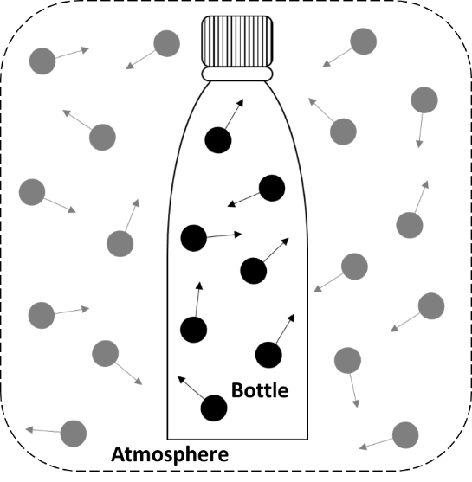
Before cooling |  | After cooling

Additional notes.

Station 2
Aim: To determine the relationship between pressure and volume

Procedure | Observations
- Place three marshmallows in the side arm flask and then seal with the stopper.
- Ensure the rubber hose is connected between the side arm and the vacuum pump.
- Turn on the vacuum pump to reduce the pressure in the flask.
- Record you observations.
- Turn off the vacuum pump.
- Put the used marshmallows in the bin.

Make a conclusion about the relationship between pressure and volume.

Draw a diagram to represent what is occurred at the particle level after the pressure was reduced.

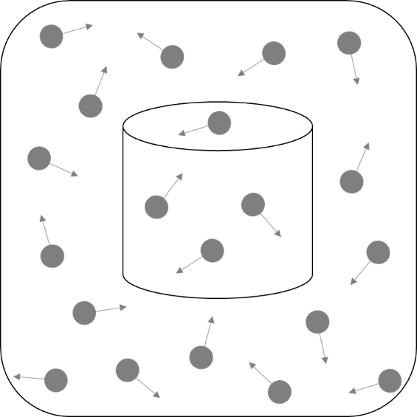
Atmospheric pressure |  | After reducing pressure

Additional notes.

Station 3
Aim: To determine the relationship between the amount of gas (yes, number of mole!) and volume

- Eliminate all air from the syringe by pushing the plunger all the way in.
- Take one conical flask containing 0.50 g of sodium hydrogen carbonate, NaHCO₃.
- Measure 50 mL of vinegar using a measuring cylinder.
- Add the 50 mL of vinegar to the conical flask and immediately connect the rubber stopper/syringe apparatus and shown in the diagram.
*NOTE: Hold syringe horizontally.

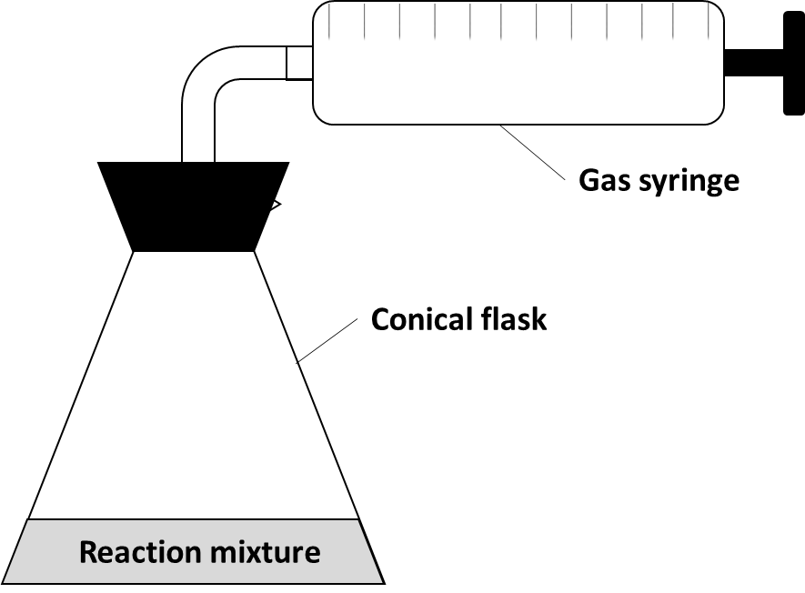

- Record you observations.

- Take a second conical flask containing 0.50 g of sodium hydrogen carbonate, NaHCO₃.
- Dilute vinegar by adding 5 mL of vinegar to a 50 mL measuring cylinder and making the solution up to 50 mL with water.
- Add the 50 mL of diluted vinegar to the conical flask and immediately connect the rubber stopper/syringe apparatus and shown in the diagram.
- Record you observations.

Make a conclusion about the relationship between the number of mole of a gas and volume.

Draw a diagram to represent what is occurred at the particle level as the number of mole of CO₂ increased.

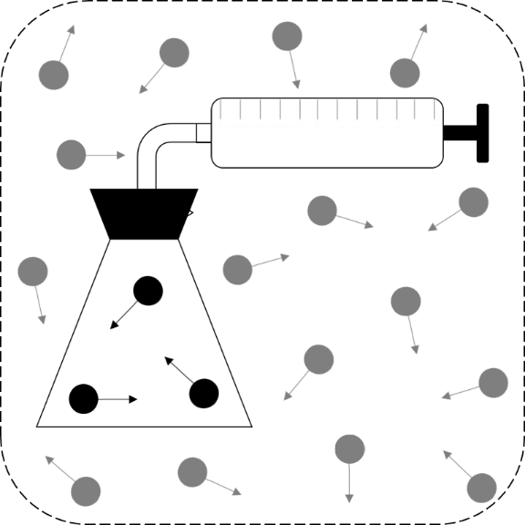
Reaction with dilute acid |  | Reaction with concentrated acid

Additional notes.

