**Model building practical activity: Stereoisomers**

(Melbourne University November Lectures workshop; adapted by Penny Commons and Kris Freebairn)

**Introduction**

Isomers are molecules that have the same molecular formula but a different structure. There are two types of isomers: structural and stereoisomers.

Structural isomers have different connectivity, for example, 2-chloropentane and 3-chloropentane.

Stereoisomers include optical isomers and geometric isomers. In stereoisomers the connectivity is the same, but the orientation in space with respect to a chiral centre or a double bond is different. The two types of stereoisomers you need to study are:

* Optical isomers, which contain a chiral centre
* Geometric isomers, which contain a double bond.

Chiral molecules, which are optically active and sometime called optical isomers, contain a carbon atom which has 4 different groups bonded to it. The mirror image of such a molecule is not superimposable and these two molecules are called a pair of enantiomers and each is optically active.

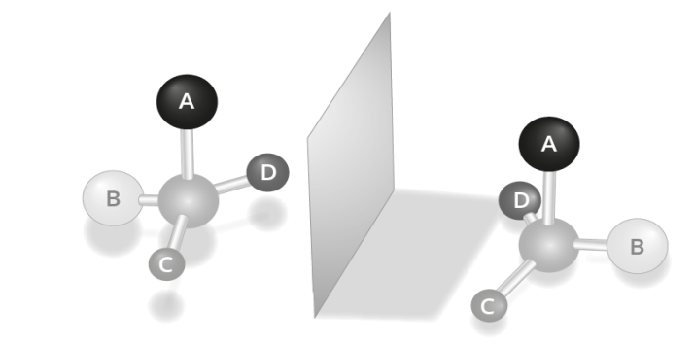

On the other hand, geometric isomers contain a double bond between 2 carbon atoms with 2 different groups bonded to the carbon atoms at each end of the double bond. In these molecules, the molecule can form with the two groups at the ends of the double bond being differently orientated with respect to the double bond. We can distinguish between these molecules using the labels *cis* and *trans*.

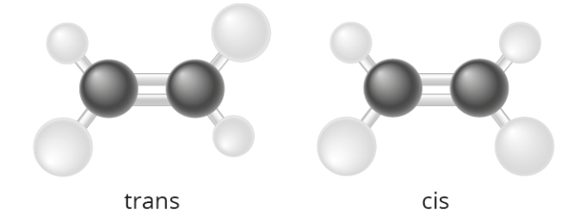

The simplest way to learn about stereoisomers is to make models and discuss the differences.

**Aim**

* To identify the asymmetric (chiral) centres in an organic molecule.
* To represent the spatial arrangement of chiral molecules on paper.
* To identify and label simple geometric isomers using the *cis and trans* descriptors.

**Materials**

Model kit between 2 students

**Procedure and questions**

**Optically active isomers**

1. How could you see if a compound were possibly optically active?

______________________________________________________________________________________________________________________________________________________________

1. What is meant by the terms chiral or asymmetric?

______________________________________________________________________________________________________________________________________________________________

1. Place an asterisk (*) by each of the chiral centres contained in molecules shown below.

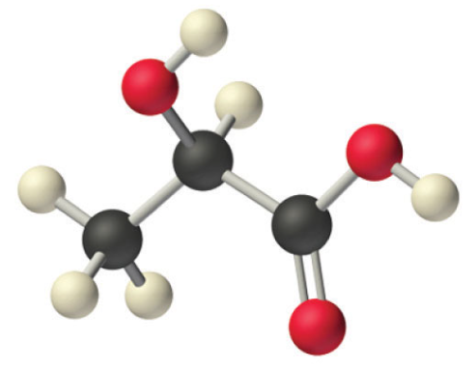

1. 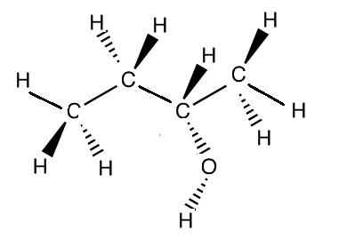 b.
2. 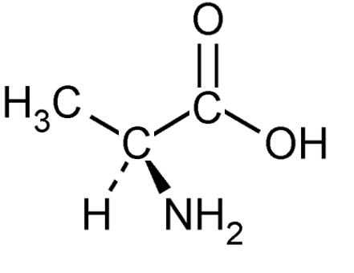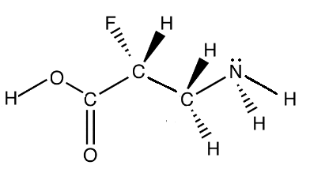 d.

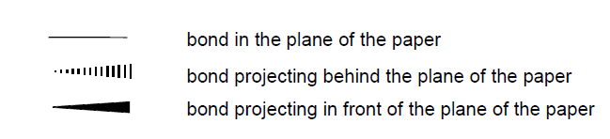

**Key:**

1. Using the model-building kits provided, construct chloromethane and its mirror image.
   1. Using the models determine whether these molecules are superimposable.
   2. Are these molecules optically active stereoisomers? Why/why not?

______________________________________________________________________________________________________________________________________________________________

1. Using the model-building kits provided, construct the molecule bromochloromethane and its mirror image.
   1. Using the models determine whether these molecules are superimposable.
   2. Are these molecules optically active stereoisomers? Why/why not?

______________________________________________________________________________________________________________________________________________________________

1. Using the model-building kits provided, construct molecule bromochlorofluoromethane and its mirror image.
   1. Using the models determine whether these molecules are superimposable.
   2. Are these molecules optically active stereoisomers? Why/why not?

______________________________________________________________________________________________________________________________________________________________

1. (a) Using the model-building kits provided, construct the molecule CH3CH(OH)CH2CH3 and its mirror image.

(b) Using the models determine whether these molecules are superimposable. Are they optically active stereoisomers? Why/ why not?

______________________________________________________________________________________________________________________________________________________________

(c) Reproduce these 3-D models on paper by completing the tetrahedral 3-dimensional diagrams shown below for both models. The dark wedge () represents for 'out of the plane' and dotted (dashed) lines () for 'into-the plane' bonds.



1. Write a conclusion based on your observations in Questions 4, 5, 6 and 7.

____________________________________________________________________________________________________________________________________________________________________________________________________________________________________________________________________________________________________________________________

1. Using the model-building kits provided, construct a model of but-2-ene.
   1. Draw a 3D drawing of but-2-ene in the space below.
   2. Create an identical molecule of but-2-ene, but swap the groups at one end of the double bond around so that the molecules are not superimposable. Draw a 3D representation of this molecule in the space provided below.
   3. Label the molecules below as *cis* or *trans*.

**Diagram of the geometric isomers for but-2-ene:**

1. Using the model-building kits provided, construct a model of 1,2-dichloroeth**ane**.
   1. Draw a 3D diagram of the molecule below.
   2. Using the model-building kits provided, construct a mirror image of the molecule above.
   3. Using the models determine whether these molecules of 1,2-dichloroethane are superimposable. Are these molecules stereoisomers? Explain.

______________________________________________________________________________________________________________________________________________________________

1. Draw a 3D drawing of 1,2-dichloroeth**ene** in the space below.
   1. Create an identical molecule of 1,2-dichloroethene, but swap the groups at one end of the double bond around so that the molecules are not superimposable. Draw a 3D representation of this molecule in the space provided below.
   2. Label the molecules below as *cis* or *trans*.

**Diagram of the geometric isomers for 1,2-dichloroethene:**

(c) Explain why 1,2-dichloroeth**ene** has stereoisomers but 1,2-dichloroeth**ane** doesn’t.

______________________________________________________________________________________________________________________________________________________________

* 1. Label the following compounds (a-f), *cis*, *trans* or *will not have a geometric isomer*.
  2. Give the name for each compound a-f.

1. b. c.

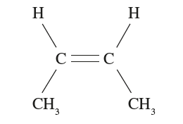 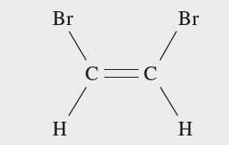 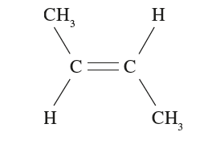

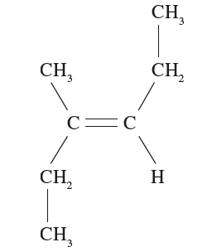

d. e. f.

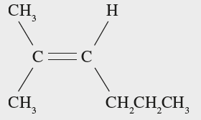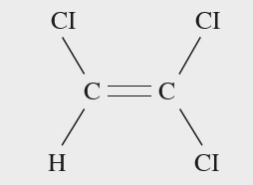

**Conclusion**

______________________________________________________________________________________________________________________________________________________________________________________________________________________________________________________