Demonstration: Oxidation of alcohols
Teacher notes
Teachers are advised they must do their own risk assessment to determine if this activity is safe to perform in their school. Potassium permanganate solution is used as an alternative to potassium dichromate solution.

Teacher preparation and organisation
Students could do this experiment in 20 minutes, but it is suggested it is performed as a teacher demonstration. Primary, secondary and tertiary alcohols can be distinguished by the rate of reaction, though no attempt is made to identify the products. It is important to emphasise the need for acid in the reaction mixture.

The alcohols can be stored in plastic dropping bottles and easily dispensed. The main difficulty arises from the fact that if the bottles are squeezed too hard the alcohols come out of the bottle in a stream (because of their low surface tension). The bottles must be handled carefully and some practice is required before proceeding with this experiment.

For the primary alcohols (ethanol and propan-1-ol), the permanganate turns colourless after a few minutes. The secondary alcohol (propan-2-ol) is slower. The tertiary alcohol (2-methylpropan-2-ol) is not oxidised at all.

Discussion could continue to the products of oxidation (aldehydes, then carboxylic acids for primary alcohols; ketones for secondary alcohols), and students could draw the relevant alcohol and oxidation product structures in their notebooks.

The results are more clearly observed using a well plate, rather than semi-micro test tubes, as shown by the photo below from Loreto College.

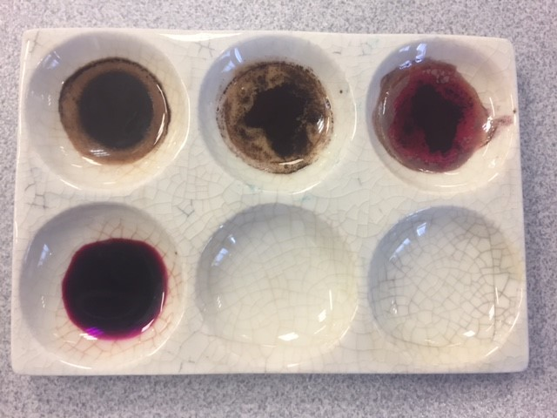

Introduction
This micro-scale demonstration investigates the effects of adding acidified potassium permanganate to primary, secondary and tertiary alcohols.
Materials
- The following alcohols in dropping pipettes:
  - Ethanol
  - Propan-1-ol
  - Propan-2-ol
  - 2-Methylpropan-2-ol
- 10 mL measuring cylinder
- 8 well x dimple trays (5 semi-micro test tubes in a test tube rack can be used instead if you use a white tile as a background)
- glass rod
- plastic dropping bottles
- 5mL 0.1 M potassium permanganate solution
- 2 mL 1 M sulfuric acid

Procedure
1. Take approximately 2 mL of potassium permanganate solution in a measuring cylinder and add about 1 mL of dilute sulfuric acid. Stir with a glass rod.
2. Put 10 drops of the acidified potassium permanganate solution into each of the wells/dimples A1 – A4 and B1 (see diagram below).
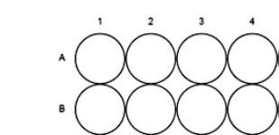
3. Add two drops of each of the alcohols to the wells as follows in the table below: record observations here.
Test tube number: | Alcohol | Observations after 5 minutes | Observations after 15 minutes
A1 | Ethanol
A2 | Propan-1-ol
A3 | Propan-2-ol
A4 | 2-methylpropan-2-ol (t-butanol)
B1 | No alcohol

4. Observe the test tubes or wells and record any colour changes you see after 5 and 15 minutes. Do not put any alcohol into well/dimple B1.

Questions:
- What is the aim of test tube B1?
_________________________________________________________________________________________________________________________________________________________________________________________________________________________________
- Which alcohols appeared to react with the acidified potassium permanganate solution?
______________________________________________________________________________________________________________________________________________________
- Classify the four alcohols as primary, secondary or tertiary.
Primary: ___________________________________________________________________
Secondary: _________________________________________________________________
Tertiary: ____________________________________________________________________
- In terms of their structure, what characterises alcohols as primary, secondary or tertiary?
_________________________________________________________________________________________________________________________________________________________________________________________________________________________________
- What is the organic product of the oxidation of a primary alcohol?
___________________________________________________________________________
- What is the organic product of the oxidation of a secondary alcohol?
___________________________________________________________________________
- What is the organic product of the oxidation of a tertiary alcohol?
___________________________________________________________________________
- Write the half equation for the reduction of the acidified permanganate ion (MnO₄⁻) to Mn²⁺ ions.
___________________________________________________________________________
- Write the half equation for the oxidation of ethanol to ethanoic acid.
___________________________________________________________________________
- Combine the two half equations in questions 8 and 9 to form the overall ionic redox equation for the oxidation of ethanol to ethanoic acid using acidified KMnO₄ solution.
___________________________________________________________________________
- Name the oxidising agent in the reaction in Q10 ____________________________________
- Secondary alcohols cannot be oxidised to a carboxylic acid; instead they only form a ketone. Write the half equation for the oxidation of propan-2-ol (CH₃CHOHCH₃) to propanone (CH₃COCH₃).
___________________________________________________________________________
- Given that the primary alcohol oxidises to the corresponding carboxylic acid but the secondary alcohol oxidises to a ketone, what simple test could you perform on the oxidation product to distinguish between the two types of reaction?
__________________________________________________________________________________________________________________________________________________________________________________________________________________________________________________________________________________________________________________________________________________________________________________________________________________________________________________________________
- Suppose you have three unlabelled alcohols, a primary, a secondary and a tertiary alcohol. What tests/reactions could you perform to distinguish between the three?
__________________________________________________________________________________________________________________________________________________________________________________________________________________________________________________________________________________________________________________________________________________________________________________________________________________________________________________________________

Penny Commons, Jennie Eggleston, 2016

